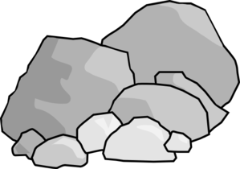
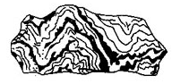
Rocks
Metamorphic
Rock
Types of Rocks:
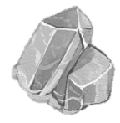
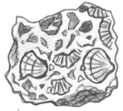
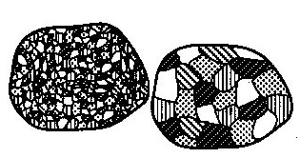
Minerals
Definition:
Characteristics:
Uses:
Identification:
Sedimentary Rock
Igneous Rock
Rock
Cycle
Rock
Cycle
Rock
Cycle
Rock Composition:

